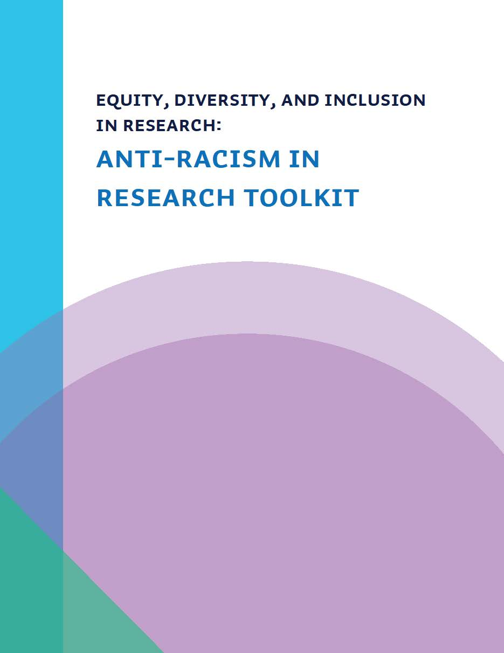
Developed for Royal Roads University
by Dr. Nicole Kaniki in February 2023

Acknowledgment of Traditional Lands
Royal Roads University acknowledges that the campus is on the traditional Lands of the Xwsepsum (Esquimalt) and Lekwungen (Songhees) ancestors and families. It is with gratitude that we live, work and learn here where the past, present, and future of Indigenous and non-Indigenous students, faculty and staff come together.
In honour of the Xwsepsum (Esquimalt) and Lekwungen (Songhees) ancestors, Hay’sxw’qa si’em (hy-sh-kwa sea-em)! This means, "Thank you, respected or honourable one."
Click here to listen to the Royal Roads University Traditional Welcome.
Harvested and carved by Tsawout artist Tom Lafortune with the assistance of
Howard LaFortune Jr., the name of this 25-foot-tall pole is “S’ael”, a Sencoten word for harmony.

Anti-Racism in Research Toolkit
Contents
Acknowledgment of Traditional Lands 2
Accessibility Statement 4
Background Purpose 5
Framing: The Importance of Anti-Racist Research 6
Research Design: Core Principles 8
Research Design: Inclusive Research Teams 10
Research Design: Anti-Racist Methodologies and Methods 13
Conducting Research: Data-Collection and Analysis 15
Research Design: Budgeting 17
Dissemination 19
Works Cited 21
Further Readings 22
The Author 23

Accessibility Statement
This Toolkit includes the following accessibility practices:
- MS Word’s built-in Headings
- Atkinson Hyperlegible Font – This font is open access for print and web use
- Table of Contents created using MS Word’s built-in templates
- Numbered and bullet-point lists
- Accessibility Statement describing the design, format, and navigation options
- Navigation can be done using either a keyboard or mouse
- Footnotes are in 12-point font instead of the conventional 10-point to improve readability
- Modified American Psychological Association (APA) style emphasizes accessibility over compliance with style rules
- Each main word in the titles of articles and books cited in the References and Further Reading sections is capitalized
- Black or dark text on a white background
We recognize that access needs vary widely, and that no single document can be completely accessible to everyone. If you would like this toolkit in an alternative format, or if you have suggestions for including more options for navigation and readability, please contact researchedi@royalroads.ca.
Further Reading: The BCcampus Open Education Accessibility Toolkit incorporates core principles of accessible document design, and includes an Accessibility Statement that has served as a guide for this document.

Background Purpose

The Anti-Racism in Research Toolkit is a brief and high-level overview of anti-racist research planning and implementation. An anti-racist research approach takes into consideration the adverse historic and structural influences that have impacted all aspects of research design – influences which have both caused harm to racialized communities as well as compromised research quality and validity of results. The toolkit aims to provide:
- an overview of the importance of anti-racist research,
- a high-level summary of concepts and approaches related to anti-racism in research,
- questions for researchers to ask themselves, and actionable strategies to use when designing and implementing research projects with anti-racism and inclusion in mind, and
- additional resources for further exploration.

Framing: The Importance of Anti-Racist Research
Pulse oximeters being less valid and reliable in patients with darker skin tones^{1,2,3}, race norming in concussion testing that assumes lower cognitive functioning in Black people and therefore lower quality of care⁴, and a retracted study conducted by an all-white research team on an impoverished community of color in post-Apartheid South Africa that concluded⁵ “increased risk for low cognitive functioning, as they present with low education levels and unhealthy lifestyle behaviours.” These are only a few examples of how inappropriate use of race and racial identity in research design has had negative impacts on the health and social equity for Black, Indigenous, and People of Color.
Systemic and structural racism impacts and influences all aspects of academia, and research has been no exception^{6,7}. The lack of diverse representation of scholars, research participant populations, and a lack of understanding of race as a social construct, not a biologic or genetic factor, have led to outcomes that have excluded racialized and Indigenous peoples, and perpetuated racial stereotypes and biases. Researchers need to be able to understand race and how it should be used in research design, analysis, reporting, and knowledge mobilization to ensure historical harms are not repeated.
“Race is a social construct used to group people. Race was constructed as a hierarchal human-grouping system, generating racial classifications to identify, distinguish and marginalize some groups across nations, regions and the world. Race divides human populations into groups often based on physical appearance, social factors and cultural backgrounds⁸.” We have more similarities than differences genetically between race classifications of people,⁹ and research must use this baseline fact about race within the framework of design. Conclusions in research based on racial findings cannot be generalized outside of the populations studied, because race is not a constant biological construct, but rather a social construct that changes between societies geographically, and culturally.
Race as a categorical variable in quantitative research data collection or as a descriptor of a community in qualitative research needs to be critically evaluated for its reliability and validity. The collection of race-based data is done through self-identification, and identity is highly contextual. There is diversity within groups of races that dictates how people choose to identify and is informed by the current environment and the lived experience of the individual. For example, what makes someone Black? Is it the individual who decides or is it society? Former US president Barack Obama has a white mother and a black father, yet he identifies as black. He could just as easily identify as white as well, and so the researcher analyzing this information must consider the ways in which the data can be impacted when the variable is not stable.
Anti-racist approaches in research design and implementation are important to the research process for social change. Impactful research serves a globally diverse world, and so we must ensure that our research environment within which the research is carried out, as well as the research methods, outcomes, and knowledge mobilization reflect this commitment.

Research Design: Core Principles
Anti-racist research approaches hold themselves accountable to how race is used in the research design and research process. There are four key principles to consider in developing anti-racist research:
First, the researcher must establish their positionality to the concept of race and/or the racial group(s) they wish to include in their research design. Positionality is defined as¹⁰ “the notion that personal values, views, and location in time and space influence how one understands the world.” A researcher’s foreknowledge, understanding of the world, and biases, impact the way they perceive information and the deductions made from or about the research. Therefore, a researcher must reflect on their identity, acknowledge their personal shortcomings if they are not racialized (outsider) or how their identity as part of a group (insider) influences their lens and perspectives on the research. They must explain how they will mitigate for bias toward groups to which they do not belong, by having either a team member with expertise and/or lived experience as a racialized person. They must also indicate their awareness and commitment to not perpetuating any stereotypes or historically racist ideologies about these groups.
Figure 1 Core principles of anti-racist research approaches
Secondly, the researcher must define the use of race for their research project: what racial categories they will be examining, how the information will be collected, and how they will ensure the privacy/confidentiality and protection from discrimination for the participants. The researcher must also clearly describe the relevance of race to the research project and how it will be used within the context of the purpose of the research project.
Thirdly, researchers must be ready to challenge any stereotypes or biases that may emerge in the use of race-based data within the research process and avoid making assumptions about racial groups. Assumptions based in stereotypes and biases can cause tremendous harm and perpetuate systemic and structural inequities.
And lastly, researchers must establish their commitment to doing research with the purpose of social change. Doing research that only serves the majority, that disregards marginalized minorities rendering them visibly invisible, and that perpetuates historical harms is no longer acceptable. In this final principle, researchers are committed to examining their research process in ongoing ways and are willing to sacrifice profit for the greater good of social change and justice.
There are specific ways in which these core principles of anti-racism are to be applied to the research process. In the next few sections, we will provide more specific considerations for each part of the research process that aligns with the core principles.

Research Design: Inclusive Research Teams
The issues or missteps from the examples of race-based research gone wrong described above can largely be attributed to a lack of diversity within the research team. The research team was not diverse or did not include anyone who could advise the rest of the team that their methods were exclusionary and could lead to racial inequity. Unfortunately, the research ecosystem has been riddled with systemic and structural barriers for racialized researchers and scholars and continues to be, even as Canadian academic institutions are mandated by federal granting agencies to be more equitable and inclusive. The following are considerations for creating a more inclusive, diverse, and equitable research environment:
- Inclusive Research Environment
Anti-racism training for the research team provides team members with a common understanding of the challenges and barriers that racialized members experience, and builds skills to identify, address, and sustain an anti-racist environment. Creating an established agreement or code of conduct of anti-racist behaviors in the lab or research environment that all members commit to provides accountability and a reminder of inclusive commitments. Providing a visible list and sharing reminders of the complaints process for experiences of racism is beneficial to the racialized members, as well as non-racialized members, to proactively prevent incidents of racism. Being culturally inclusive of members who require accommodations for non-Christian religious holidays or events is an important aspect of an anti-racist and culturally inclusive research environment.
Figure 2 Summary of how to create an inclusive, diverse, and equitable research environment.
- Diverse Research Environment
Leadership carries the responsibility of identifying the social dynamics of power and privilege of themselves and their identity in relation to their team members, and those between team members. Racialized members who are in the minority may require intentional and meaningful efforts by the leader to bring them into the group. An empathetic leader can set the example of inclusivity and anti-racist behaviors in the team they are responsible for. Reflect on the diversity, or lack thereof, for the research team and the field when considering hiring for new positions or recruiting new team members. Seek to intentionally hire more racialized members if the team is homogenous. This will require efforts such as posting opportunities widely (for more than 30 days) and having a rigorous and equitable recruitment and hiring process that includes a statement about the team’s commitment to an inclusive environment and desire to create a diverse team. Sharing the opportunity with diversity groups in the field (e.g., Black in Neuro, Queer in Neuro, etc.), or on Twitter, using inclusive hashtags (e.g., #BlackInSTEM, #IndigenousInSTEM, etc.) can expand diversity of the applicant pool. Be open to work experiences that are not traditionally academic and expertise that is not the same as what is already on the team but can contribute to new perspectives.
- Equitable Research Environment
Professional development opportunities and mentorship needs to be assessed and evaluated for equity between team members. Develop an accountability measurement that ensures equal opportunities for all members, and not, for example, overburdening racialized members with EDI responsibilities or admin versus career-impact opportunities for non-racialized members. Leaders need to spend equal time with all trainees and must hold themselves accountable if more 1-on-1 time is spent with majority groups or those reflecting their own identity. Schedule designated times with trainees and mentees. Sponsorship is defined as “a relationship that produces objective career benefits for the person being sponsored, commonly called protégé. In a nutshell, a sponsor uses their power and status to advocate for a protégé’s career advancement.¹¹” Sponsorship is equally as important as mentorship and is one of the greatest barriers and challenges for racialized mentees because leaders and those in positions of power, often white, are not always willing, or mindful, to sponsor those who do not look like them for future career opportunities.

Research Design: Anti-Racist Methodologies and Methods
There are two ways we will discuss the use of race-based information in research design: (1) as a quantitative race variable, and (2) as a qualitative aspect of a population (i.e., racialized community). There are different considerations for each of these approaches for researchers to consider.

Figure 3 Considerations for collecting race-based data in research method and methodology development
Collecting race-based data, and especially disaggregated race-based data, is very new to the Canadian research landscape. Demographic data other than sex has not been collected in our healthcare system, and so the historical data available to those in health research is also limited. As we enter a new era of education and openness to discussions on the collection of more substantiative race-based data, researchers need to be mindful of the WHY, HOW, and WHAT FOR? These questions need to be justified clearly because of the potential harm to perpetuate historical oppression and bias with the data. There is still much trust building that needs to occur in Canadian research especially with racialized groups such as Black and Indigenous peoples, who historically have been marginalized with this information. Figure 3 provides a guide for researchers in both STEM and Humanities/Social Sciences fields to consider the collection of race-based information. Here are a few additional guidelines to consider¹²:
- Research with racialized communities must be collaborative and relational, not transactional.
- Seek out expertise that can provide you with perspectives on the data or the work that you may not have considered if you are not an expert on race or an “insider” to the community.
- “Nothing about us without us” - Work with not over or around racialized communities. Your research question should be shaped by the community if it is to serve the community.
- Be aware of your own confirmation bias that may impact your perspective of racial identities and how you frame their participation in your research.
- Race is a social construct; do not use it as a genetic or biological variable.
- Racial differences provide more information about racism, than about racial differences. There are as many diverse factors within racial groups as there are within the general population.
- Beware of generalizing about racial groups based on a limited research study population and applying this knowledge to a different population and context.
- Interrogate the assumptions you are making based on race to ensure they are not rooted in stereotypes or bias that shows up in your methods or approaches.
- Be willing to adopt recruitment strategies that diversify, even if you have to go above and beyond your usual practices.

Conducting Research: Data-Collection and Analysis
The collection and analysis of race-based data is contextual. The way in which race is presented in one research study can be very different from another, especially where the population changes geographically or in diversity. The data collection processes about race from communities even within the same race can change depending on the conditions of the research study and the context of the population. Researchers must examine the environment within which the information about people’s racial identity is collected, and not lose sight of this narrative when analyzing the data. Context can influence outcomes. Assess the pre-conceptions you have about a racialized community and justify how you will mitigate for harm through bias thinking. Here are a few questions you can ask about the collection and analysis of race-based data:
Race as variable
- Why are you collecting race-based data? Is it relevant to your study?
- Will you collect race-based data as aggregated or disaggregated? (i.e., Racialized (grouping) versus Black, Indigenous, South Asian, White, etc.)
- What has the historical literature shown about racial differences for the field/area/topic you are researching? Are the conclusions from these based in bias or stereotypes that cannot be generalized?
- What demographic form/categories are you using and what was the context within which it was developed or previously used? Is it applicable to how your population will choose to identify?
- Will race be a primary or secondary variable? Why?
- How will you analyze the race data and compare between group differences according to race? Is the comparison justified for potential differences and if differences are found will it explain racial differences, or racism?
- What is the diversity of the population of your research study and is it representative of the Canadian population, or the population of individuals who experience what you are researching?
- Are you able to set diversity targets for representation in your research participant pool and change strategies to meet these targets if you are not?

Race as community identity
- Does the way in which you would describe the racialized community align with the way that the community would describe themselves?
- Have you reflected on the diversity or homogeneity (e.g., mostly white) of your research participants? Could it be you’re overlooking an important aspect of your research and that your outcomes will not be generalizable to diverse populations?
- How does diversity within the racialized community impact your data collection and the outcomes?
- Are the research questions being asked in the data collection process framed in a way that empowers, OR that seeks deficits about the community?
- Are you looking to confirm a stereotype or bias about a racialized community through your data collection and analysis processes? (i.e., confirmation bias)
- If you are collecting information about the experiences of a marginalized, racialized community, do you have the skills and support in place to provide trauma-informed care?
- Will your research questions and data collection processes produce trauma or trigger post-traumatic stress?
- Do you have the skills to analyze the data from racialized communities in a way that does not perpetuate oppression, deficit thinking, or stereotypes about the racialized group?

Research Design: Budgeting
Anti-racist research takes a decolonial approach that can deviate from “research as usual” and will require additional time and financial commitment from the research team. What gets budgeted, gets done. If researchers are not budgeting for the expertise, and decolonial and culturally inclusive accommodations needed to do anti-racist research, the outcomes may do harm. Core considerations in developing anti-racist budgets:
- Anti-racist research builds relationship with community before the research grant is even developed and develops the research question with community.
- Anti-racist research budgets for expertise that mitigate for bias and oppression.
- Anti-racist research budgets for ongoing training and skill building for the research team.
- Anti-racist research is not coercive but compensates racialized participants adequately for their labour and contributions to the research, including the financial and emotional implications of participation.
- Anti-racist research empowers and listens to racialized team members and community partners, trusting they are the experts of their own experiences.
Some examples of decolonial and anti-racist approaches in research budgeting:
- Ask research partners/community what appropriate compensation they would want, and be willing to go to great lengths to get it approved. Be prepared for requests to be the first of their kind.
- Racialized communities often gather around food to share time and knowledge; be prepared to budget for catering provided by vendors from the community. Make inquiries and get rates and information of payment methods before submitting the grant.
- Hire expert EDI consultants to inform your research development if you do not have the expertise on your team. Include further budgeting in the grant for review and consulting services throughout the research process.
- If you do not have access to anti-racism and anti-oppression training for your research team at your institution, budget for training from expert consultants.
- Include anti-racism and anti-oppression topics in your research initiatives if you are hosting events or conferences. Budget for the expertise that you may need to access for these. Understand that racialized experts are on high demand, and you may need to consider compensation that is above and beyond non-racialized experts.
- If you are doing research with a racialized community about experiences of racism, budget expert counselling support (preferably racialized) for your sessions and offer these to participants. Include trauma-informed practices in your research.
- Prioritize people over profit. Budgeting strategies should always seek to prioritize the welfare and wellbeing of racialized members and participants over the research process.

Dissemination
Key considerations for anti-racist research dissemination are responsibility, accountability, and transparency.
Figure 4 Key considerations for anti-racist research dissemination
Anti-racist approaches in research dissemination start at the development of the research process, not at the end after results are obtained. Whether quantitative or qualitative research methods are used, research dissemination that is accessible, beneficial, and supports social empowerment of racialized communities must be a priority.
The following better practices support anti-racist research dissemination:
- When research outcomes include disaggregated outcomes based on race, researchers must clearly justify how they collected, analyzed, and concluded their results. If racial differences were found, they must also clearly state the limitations of the generalizability of the results to racialized populations. Researchers also have a responsibility to include in their research dissemination some education on the interpretation of race-based data within the framework for race as a social construct, and not as a biological or genetic construct for their audience.
- Be prepared to correct or hold accountable media outlets reporting the results of research that frames racialized groups at a deficit. Remember that society does not have access to the background anti-racist knowledge and approaches you used in the research process.
- Race-based research dissemination must seek to have impact for social change and empowerment of racialized people.
- Seek open access avenues for your research outputs, especially research that focuses on benefits to racialized communities.
- The use of targeted social media strategies can be tremendously effective in sharing research with racialized groups. Develop posts, documents, videos, or infographics that share the main outcomes in a culturally accessible way.
- Plan (and budget) for events with racialized communities to share the research results in a culturally safe and informal way after the research is complete. A better practice would be to do so before publication and to obtain feedback from the community about the results.
- Offer research dissemination tools in multiple languages and have the community partners review and provide feedback of all outputs before sharing.
- Be willing to use facilities in the community to meet and share results with the community.
- Use accessible, plain language in dissemination tools.
- Be prepared to continue relationships with the racialized community and allow them to have access to you as researcher beyond the publication of the research.

Works Cited
- Sjoding, M.W., Dickson, R. P., Iwashyna, T. J., Gay, S. E., & Valley, T. S. (2020). Racial Bias in Pulse Oximetry Measurement. The New England Journal of Medicine, 383(25), 2477–2478.
- Dyer, O. (2020). Pulse Oximetry may Underestimate Hypoxaemia in Black Patients, Study Finds. BMJ (Online), 371, m4926.
- Valbuena, V.S.M., Barbaro, R. P., Claar, D., Valley, T. S., Dickson, R. P., Gay, S. E., Sjoding, M. W., & Iwashyna, T. J. (2022). Racial Bias in Pulse Oximetry Measurement Among Patients about to Undergo Extracorporeal Membrane Oxygenation in 2019-2020: A Retrospective Cohort Study. Chest, 161(4), 971–978.
- Possin, K.L., Tsoy, E., & Windon, C. C. (2021). Perils of Race-Based Norms in Cognitive Testing: The Case of Former NFL Players. JAMA Neurology, 78(4), 377–378.
- Nieuwoudt, S., Dickie, K. E., Coetsee, C., Engelbrecht, L., & Terblanche, E. (2020). RETRACTED ARTICLE: Age- and Education-Related Effects on Cognitive Functioning in Colored South African Women. Aging, Neuropsychology, and Cognition, 27(3), 321–337.
- Henry, F. & Tator, C. (Editors). (2018). Racism in the Canadian University: Demanding Social Justice, Inclusion, and Equity. University of Toronto Press.
- Ibrahim, A., Kitossa, T., Smith, M. S., & Wright, H. K. (Editors). (2022). Nuances of Blackness in the Canadian Academy: Teaching, Learning, and Researching while Black. University of Toronto Press.
- National Human Genome Research Institute. (No date). Talking glossary of genomic and genetic terms.
- Rosenberg, N. A., Pritchard, J. K., Weber, J. L., Cann, H. M., Kidd, K. K., Zhivotovsky, L. A., & Feldman, M. W. (2002). Genetic Structure of Human Populations. Science, 298(5602).
- Warf, B. (Editor). (2020). Encyclopedia of Geography. Sage Publications.
- Mattingly, V., Grice, S., & Goldstein, A. (2022). Inclusalytics: How Diversity, Equity, and Inclusion Leaders use Data to Drive their Work. Mattingly Solutions.
- Gupta, T. D. (2003). Teaching Anti-Racist Research in the Academy. Teaching Sociology, 31(4), 456–468.

Further Readings
- The National Collaborating Centre for Indigenous Health (NCCIH) https://www.nccih.ca/en/
- DEI, G. J. S. (2005). Chapter One: Critical Issues in Anti-racist Research Methodologies: AN INTRODUCTION. Counterpoints, 252, 1–27.
- Strand, N. (2021). Racial Myths and Regulatory Responsibility. Journal of Law, Medicine & Ethics, 49(2), 231-240.
- De Wolfe T.J., Arefin M.R., Benezra A., Rebolleda Gómez, M. 2021. Chasing ghosts: race, racism, and the future of microbiome research. mSystems 6:e00604-21.
- Calhoun, A. (2021). The Pathophysiology of Racial Disparities. The New England Journal of Medicine. May 20, 2021, 384:e78.
- Winston, Andrew S. (2020). Why Mainstream Research Will Not End Scientific Racism in Psychology. Theory & Psychology, 30(3), 425–30.

The Author
Dr. Nicole Kaniki holds a MSc Kinesiology, and a PhD Health and Rehabilitation Sciences from Western University. More recently, she completed a MA Gender, Sexuality and Women’s Studies at Western doing research in Black Feminist Narratives in the Academy. Kaniki has a passion for social justice and uses an anti-racism and decolonization framework in her EDI work. As the Director of EDI in Research and Innovation at the University of Toronto, she examines, advocates and advances EDI in all aspects of research, innovation and entrepreneurship. Kaniki is also the founder and Director of Senomi Solutions Inc. that delivers a wide range of strategic planning, evaluation, and training services to support and sustain organizational equity and inclusion.

