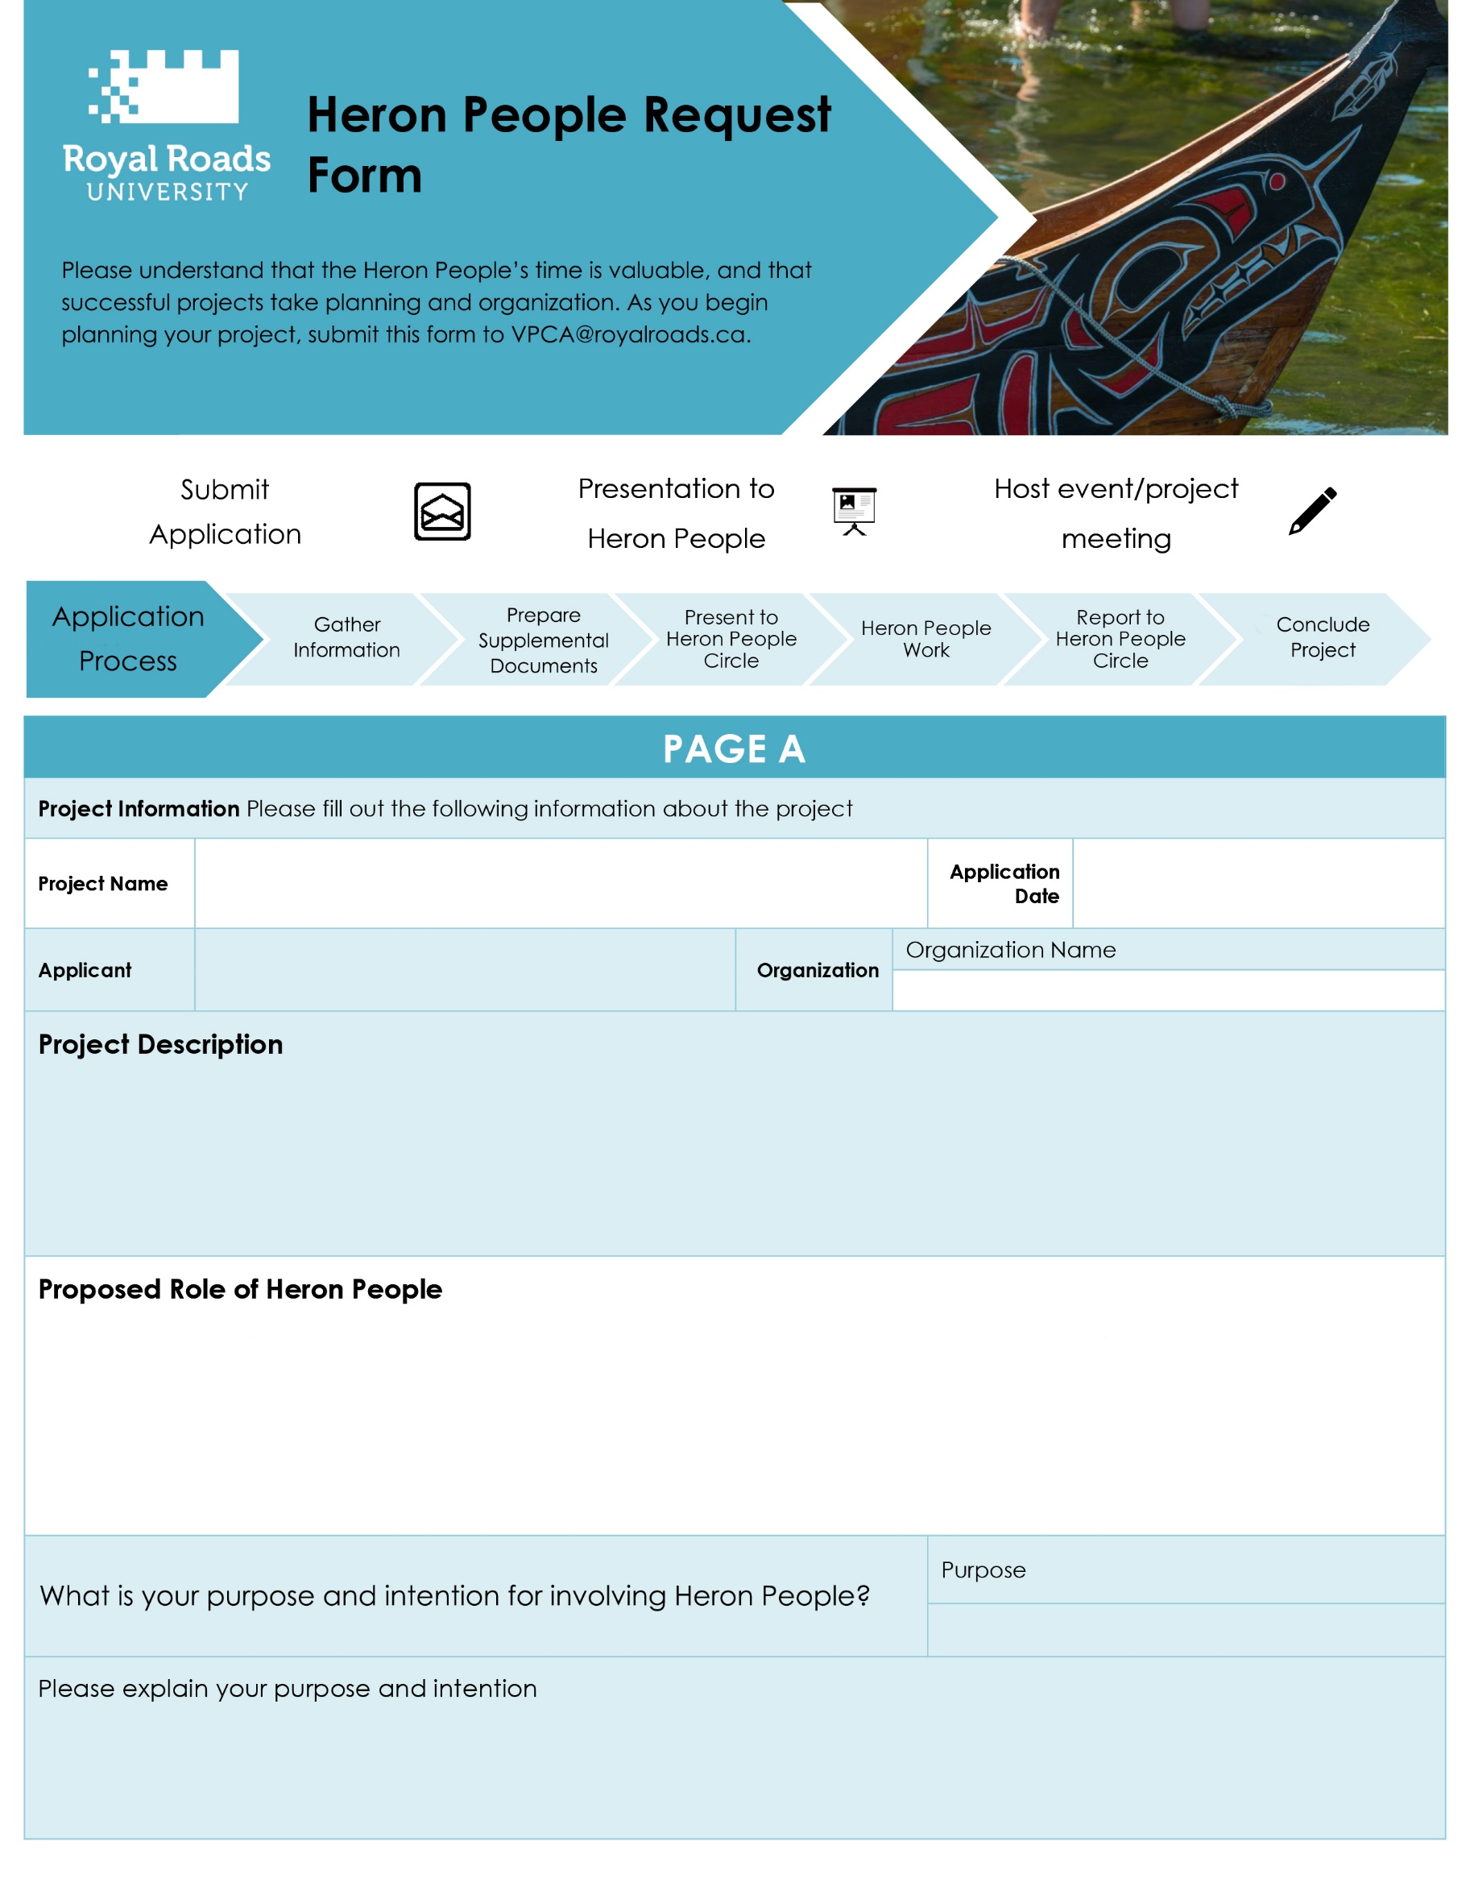

|  |
| --- |
| Click here to enter applicant name(s) |

|  |
| --- |
| Provide a description of the project/event here |

|  |
| --- |
| Provide a description for how the Heron People will be actively involved in the project |

|  |
| --- |
| Describe purpose or intention |

|  |
| --- |
| *If other, please specify* |

|  |
| --- |
| Click here to enter project name |

|  |
| --- |
| Select one of the following |

|  |
| --- |
| Select date with dropdown |

|  |
| --- |
| Organization Name |

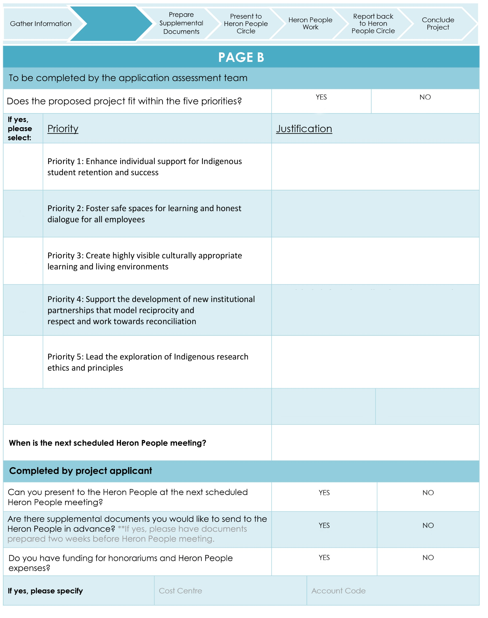

|  |  |
| --- | --- |
|  |  |

|  |  |
| --- | --- |
|  |  |
|  |  |
|  |  |

|  |
| --- |
| Provide brief explanation how proposed project meets Priority 1 |
| Provide brief explanation how proposed project meets Priority 2 |
| Provide brief explanation how proposed project meets Priority 3 |
| Provide brief explanation how proposed project meets Priority 4 |
| Provide brief explanation how proposed project meets Priority 5 |

|  |
| --- |
| Check calendar and select date from dropdown |

|  |
| --- |
| Cost centre |

|  |
| --- |
| Account Code |

|  |
| --- |
| Specify here |